Practical no. 14
Name :- Danish Altaf Solkar Enrolment no. :-24111590805
Class :- CO3K – B Subject :- OOP
Aim :- Write programs to implement Virtual Base Class.
Program :-
#include<iostream.h>
#include<conio.h>
class Master{
public:
char name[40];
int code;
};
class Account:virtual public Master{
public:
int basic_pay;
};
class Admin:virtual public Master{
public:
int experience;
};
class Employee:public Account, public Admin{
public:
int gross_salary;
void accept(){
cout<<"\nEnter your Name :- ";
cin>>name;
cout<<"\nEnter your Code :- ";
cin>>code;
cout<<"\nEnter your Basic Pay :- ";
cin>>basic_pay;
cout<<"\nEnter your Experience :- ";
cin>>experience;
cout<<"\nEnter your Gross Salary :- ";
cin>>gross_salary;
}
void display(){
cout<<"\nName :- "<<name;
cout<<"\nCode :- "<<code;
cout<<"\nBasic Pay :- "<<basic_pay;
cout<<"\nExperience :- "<<experience;
cout<<"\nGross Salary :- "<<gross_salary;
}
};
void main(){
Employee e;
clrscr();
cout<<"\nEnter Employee Details :- ";
e.accept();
cout<<"\nEmployee Details are :- ";
e.display();
getch();
}
Output :-
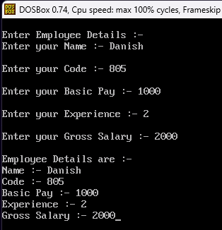

Program :-
#include<iostream.h>
#include<conio.h>
class Student{
public:
int rollno;
void getnumber(){
cout<<"\nEnter your Roll No. :- ";
cin>>rollno;
}
void putnumber(){
cout<<"\n\tRoll No. :- "<<rollno<<"\n";
}
};
class Test:virtual public Student{
public:
int part1,part2;
void getmarks(){
cout<<"\nEnter marks :- ";
cout<<"\nPart 1 :- ";
cin>>part1;
cout<<"\nPart 2 :- ";
cin>>part2;
}
void putmarks(){
cout<<"\n\tMarks Obtained :- \n";
cout<<"\n\tPart 1 :- "<<part1;
cout<<"\n\tPart 2 :- "<<part2;
}
};
class Sports:virtual public Student{
public:
int score;
void getscore(){
cout<<"\nEnter Sports Score :- ";
cin>>score;
}
void putscore(){
cout<<"\n\tSports Score :- "<<score;
}
};
class Result:public Test, public Sports{
public:
int total;
void display(){
total=part1+part2+score;
cout<<"\n\tStudent details are :- ";
putnumber();
putmarks();
putscore();
cout<<"\n\tTotal Score :- "<<total;
}
};
void main(){
Result r;
clrscr();
r.getnumber();
r.getmarks();
r.getscore();
r.display();
getch();
}
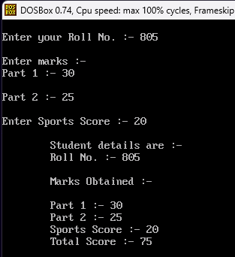
Output :-

